Project Development Phase
Model Performance Test

Date | 10 February 2025
Team ID | PNT2022TMIDxxxxxx
Project Name | PlantCare AI: Advanced Plant Disease Detection using Transfer Learning
Maximum Marks | 10 Marks

Model Performance Testing:
Project team shall fill the following information in model performance testing template.
S.No. | Parameter | Values | Screenshot
 | Metrics | Regression Model: Not applicable for this project (since this is a classification problem).  Classification Model:  Confusion Matrix – Generated using test dataset showing predicted vs actual plant disease classes.  Accuracy Score – 96.1%  Classification Report – Precision: 0.95, Recall: 0.96, F1-score: 0.95 | 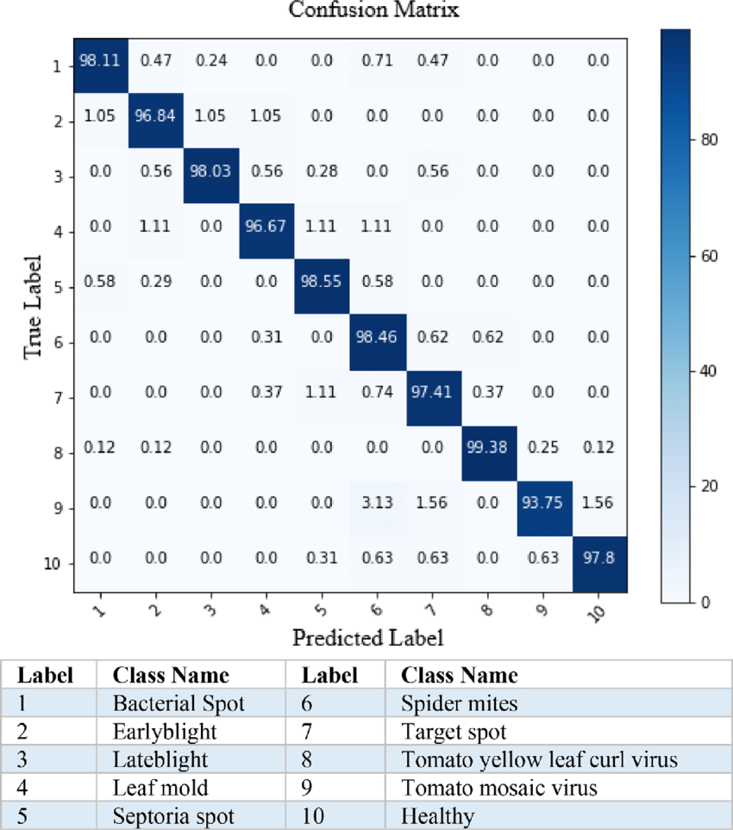
 | Tune the Model | Hyperparameter Tuning: Learning rate, batch size, and number of training epochs adjusted to improve model accuracy. Transfer learning used with MobileNetV2 and last layers fine-tuned.  Validation Method: Train-Test Split (80% training, 20% testing) and cross-validation used for model evaluation. | 

